E-GOVERNANCE

“E-GOVERNANCE ON EDUCATION IN INDIA”

“SUBMITTED TO”:

**PROF.MAHESHWARI.N**



“SUBMITTED BY”:

G.PAVAN KUMAR-“16MIS1097”

P.HARIKRISHNA-“16MIS1026”

K.HARI KRISHNA REDDY-“16MIS110”

**ABSTRACT:**

E-Government can transform citizen service, provide access to information to empower citizens, enable their participation in government and enhance citizen economic and social opportunities, so that they can make better lives, for themselves and for the next generation. Through the e-Governance, the government services will be made available to the citizens in a convenient, efficient and transparent manner. The three main target groups that can be distinguished in governance concepts are Government, citizens and businesses/interest groups.

**INTRODUCTION:**

School Education is a Concurrent Subject under Constitution of India and falls within the domain of Center and States / UTs. At the Center, School Education is dealt by Department of School Education and Literacy of Ministry of Human Resource Development (MHRD). At the State Level, School Education is dealt by Education Department. In a few States, Department for Backward Classes and Minorities and Department of Social Welfare also play a significant role in administration of hostels, schools, and disbursement of scholarships to students.

Change has been happening at an uneven pace in anygrowth-oriented industry, and the education sector is noexception. Rapid growth in the field of education has made governance in academic sector a very complex task.The 21stcentury has witnessed tremendous advancements in technology which has led to far-reaching developments in the administrative system. Cost-effective technology combined with the flexibility in learning and administrative activities is essential to enhance efficiency. Computers can be used extensively for educational administration.

There are some of the areas where computers can be used for effective educational Admin-stration:

* General Administration.
* Pay Roll and Financial Accounting.
* Administration of Student Data.
* Inventory Management.
* Personnel Records Maintenance.
* Library System.

Information and Communication Technology(ICT) plays a vital role in supporting powerful, efficient management and administration in education sector. it is specified that technology can be used right from student administration to various resource administration in an education institution.Sharad Sinha mentioned the various administrative challenges for Indian education system of the 21st century as given below:

* Global and local challenges.
* Universal and individual challenges.
* Competition and equity challenges.
* Extraordinary expansion of knowledge.

Moreover many studies revealed the need for ICT integration into administrative activities of higher education institutions.The various ways of introducing technology in education institution administration are the following:

* Sending e-mail notices and agendas to staff, rather than printing and distributing them.
* Submission of lesson plans through e-mail.
* Foster technology growth by asking parents to write e-mail addresses on medical forms.
* Insist that all teachers create a class Web page.
* Attend technology conferences to see what other schools are doing, what other teachers are doing to integrate technology,and what principals are doing to encourage the use of tech-nology in their schools and classrooms.
* Admissions through web-enabled services.
* All day-to-day activities of the institution (General Administration).
* Staff administration.
* Single Window System for students.

NECESSITY OF E-GOVERNANCE IN HIGHER EDUCATION:

If the quality of our higher education system has to be improved to make these institutes really word class, then there is noalternative to the introduction of e-governance in this sphere at the fastest possible pace. Implementation of e-governance in technicaland vocationalinstitutes will enable their effective & real time monitoring by Government/the regulatory bodied & other stakeholders their own managements, parents of the students & the society, thereby forcing them to maintain quality & become more responsible. E-governance process brings transparency in the system, so e-governance initiatives in the field of higher education will help reduce the corruption up to a large extent. The introduction of e-governance in higher education is one such concept that can empower the governing bodies to administer the progress of the education plan in the whole country and serves various stakeholders in a much better ways.

According Info Dev Report(2002) an effective e-governance satisfies these following needs:

* Providing greater access to government information.
* Promoting “public engagement” by enabling the public to interact with government officials.
* Making government more accountable by making its operations more obviousand thus reducing the opportunities for corruption.
* Providing development opportunities, especially benefiting rural and traditionally underserved communities.

AIM:

“Analyse all the data obtained through the Government researches on similar topics and try to identify some of the “poorly performing states” using the Data Mining tools and data sets”.

DATA SET**:**

“Schools having computers statewide and which are divided within themselves into different categories”.

* From: “www.Data.gov.in”

TECHNIQUES USED:

* DATAMINING:
* CLUSTERING.
* PYTHON:
* CLUSTERING::“K-MEANS”
* ELBOW MEATHOD.

CLASS LABELS:

“STUDENT POPULATION USING COMPUTERS” W.R.T OF EACH STATE (2015-2016 ).

CLUSTERING TECHNIQUE:

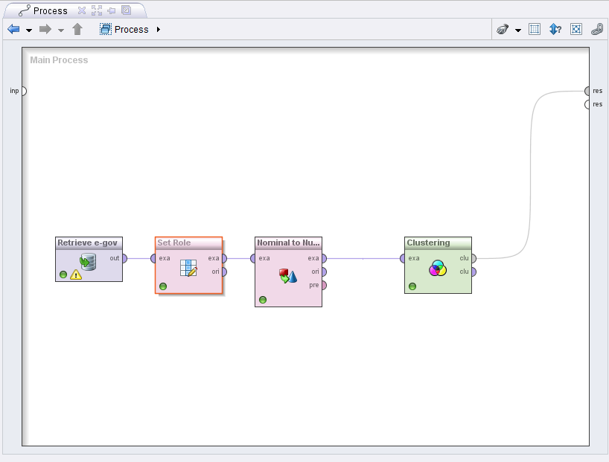

CLUSTER VIEW:

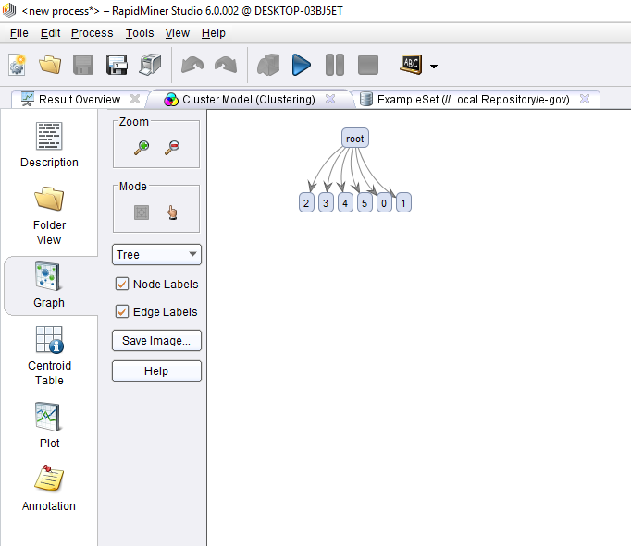

DETAILED VIEW OF EACH CLUSTER:

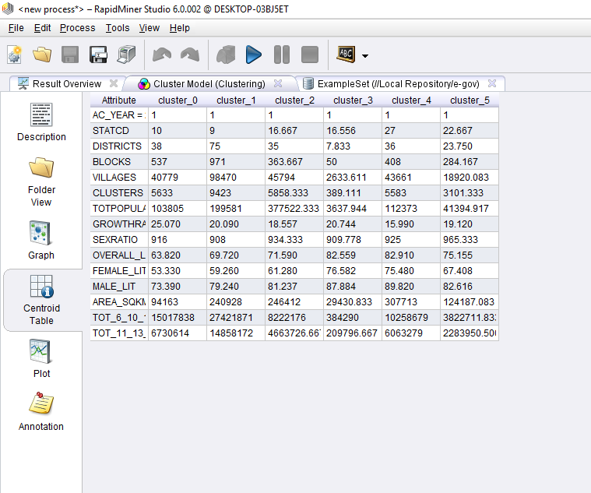

PLOTTED GRAPH:

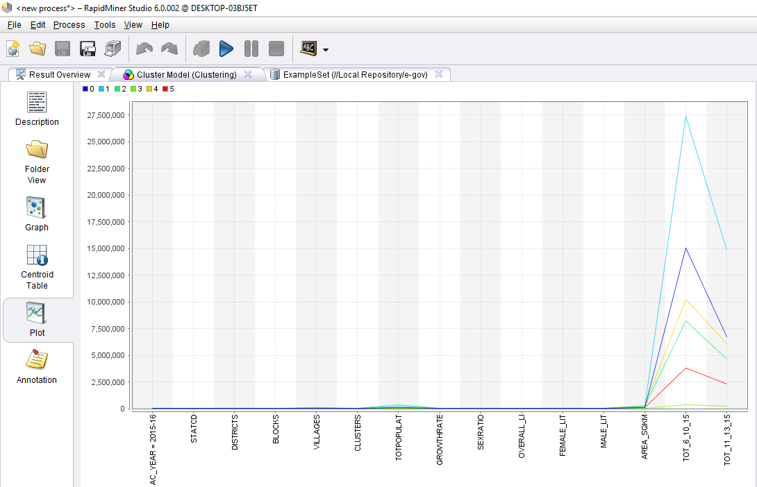

INFERENCE:

From this data mining techniques the clustering of data has made possible to achieve :

* Analyse the states that are divided into clusters.
* Anaylyse states that are performing well.

ADVANTAGES:

* Analysis made easy compared to other researching statistics.

DISADVANTAGES:

* Clusters are set by “Us” which sometimes distrubs the quality and efficiency.

PYTHON CODE:

# K-Means Clustering

# Importing the libraries

import numpy as np

import matplotlib.pyplot as plt

import pandas as pd

# Importing the dataset

dataset = pd.read_csv('education.csv')

X = dataset.iloc[:, [13,15]].values

# y = dataset.iloc[:, 3].values

# Splitting the dataset into the Training set and Test set

"""from sklearn.cross_validation import train_test_split

X_train, X_test, y_train, y_test = train_test_split(X, y, test_size = 0.2, random_state = 0)"""

# Feature Scaling

"""from sklearn.preprocessing import StandardScaler

sc_X = StandardScaler()

X_train = sc_X.fit_transform(X_train)

X_test = sc_X.transform(X_test)

sc_y = StandardScaler()

y_train = sc_y.fit_transform(y_train)"""

# Using the elbow method to find the optimal number of clusters

from sklearn.cluster import KMeans

wcss = []

for i in range(1, 11):

kmeans = KMeans(n_clusters = i, init = 'k-means++',max_iter=300,n_init=10, random_state = 0)

kmeans.fit(X)

wcss.append(kmeans.inertia_)

plt.plot(range(1, 11), wcss)

plt.title('The Elbow Method')

plt.xlabel('Number of clusters')

plt.ylabel('WCSS')

plt.show()

# Fitting K-Means to the dataset

kmeans = KMeans(n_clusters = 3, init = 'k-means++',max_iter=300,n_init=10, random_state = 0)

y_kmeans = kmeans.fit_predict(X)

# Visualising the clusters

plt.scatter(X[y_kmeans == 0, 0], X[y_kmeans == 0, 1], s = 100, c = 'red', label = 'Cluster 1')

plt.scatter(X[y_kmeans == 1, 0], X[y_kmeans == 1, 1], s = 100, c = 'blue', label = 'Cluster 2')

plt.scatter(X[y_kmeans == 2, 0], X[y_kmeans == 2, 1], s = 100, c = 'green', label = 'Cluster 3')

plt.scatter(kmeans.cluster_centers_[:, 0], kmeans.cluster_centers_[:, 1], s = 300, c = 'yellow', label = 'Centroids')

plt.title('Education level between 2015-2016')

plt.xlabel('literacy using computers')

plt.ylabel('general population')

plt.legend()

plt.show()

OUTPUTS:

ELBOW MEATHOD:

* “Defines how many clusters need to be there.”
* Output=“K=3”

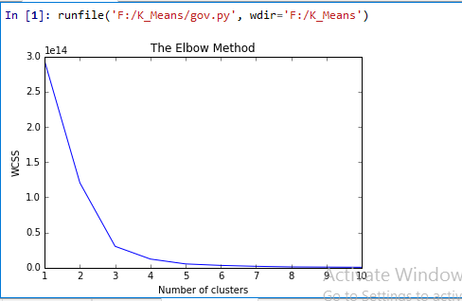

DATA DESCRIPTION:

* Wcss: “Elbow meathod”.
* X:population using computers in “2015”.
* Y:population using computers in “2016”.

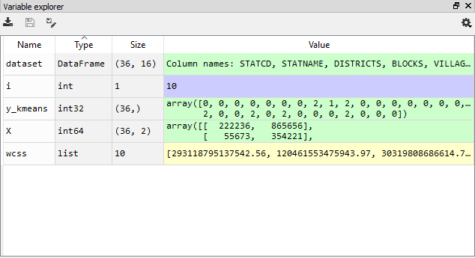

SCATTER PLOTTER GRAPH:

* Since “k=3”.
* Cluster “1”-“red”.
* Cluster “2”-blue”.
* Cluster “3”-green”.
* Centroids-“yellow”.
* Distance Formula-“Manhattan Distance”.

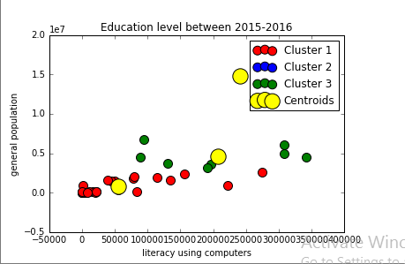

INFERENCE:

From this data mining techniques the clustering of data has made possible to achieve :

* Analyse the states that are divided into clusters.
* Anaylyse states that are performing well.

ADVANTAGES:

* Clusters are decided using the ELBOW meathod.
* Programming languages like “python” require you give the computer very detailed, step-by-step instructions of what to do.

CONCLUSION

By using such techniques we can analyse the Situation of Educational institutes and efficiency of “E-Governance” on education as well as we can try to improve the situation of poorly performing states and build new measures to make them “Perform Better”. E-governance can create the transparency between the universities, colleges and students. It will bring forth, new concepts of governance, both in terms of needs and responsibilities. Many problems of higher education system can be solved by the “E-GOVERNANCE”.